Tableau Project Solutions

# XYZ company training client performance data. needs to look back to its historical performance and business cycle in a way that will provide some meaningful information to take the strategic and informed decision for its

expansion. The management of XYZ wants to outsource this task, to analyze the trend, pattern, forecast, and analysis.

XYZ Training & Development Performance

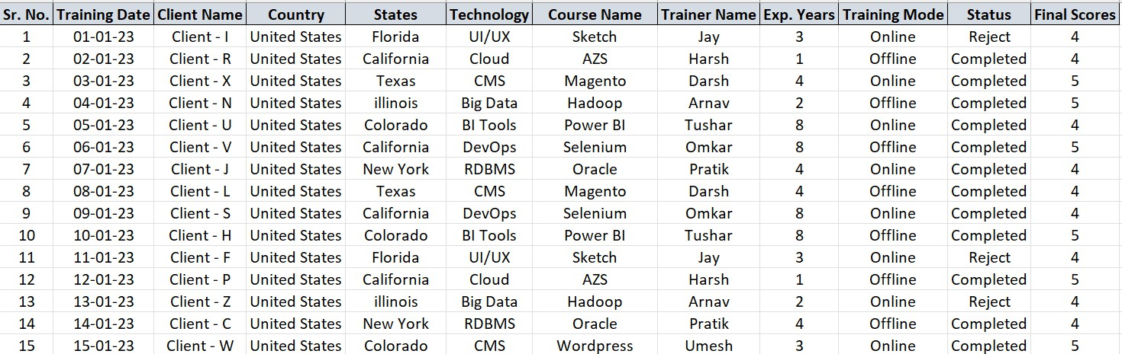

**Visual Insights**

# Make number cards for the entire clientele, the technology, the courses, and the trainer

Like:



Drag the Client Name field into the Text

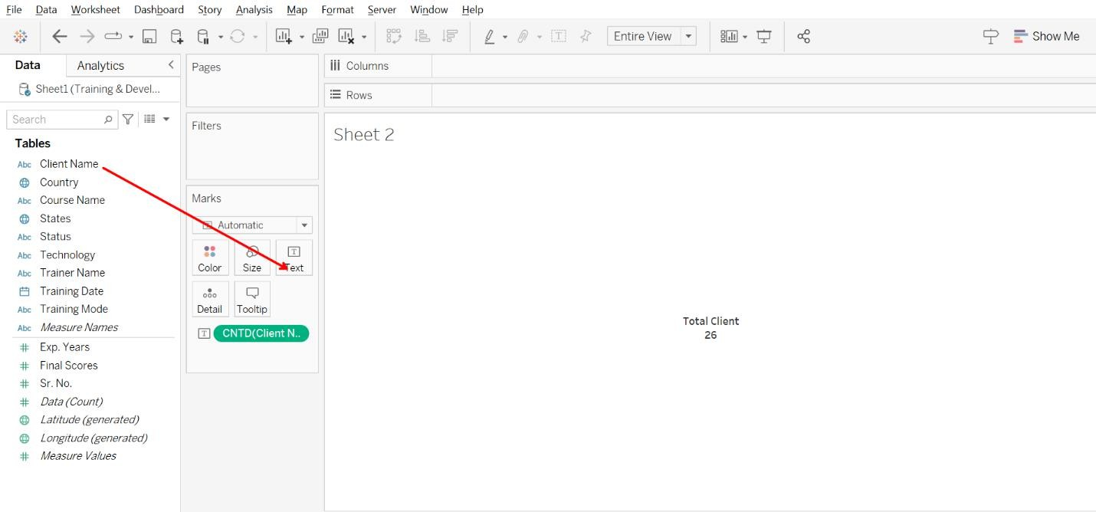

# Make a pie chart that displays the number of clients per training mode.

Like:

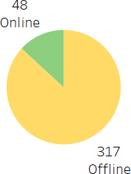

**Step 1**: Drag the Client Name field into the Text

**Step 2**: Drag the Training Mode field into the Color

**Step 3**: Open the drop-down from the client’s name and select measures then Count

**Step 4**: Select or Click on Pie Chart from Show me

**Step 5**: Select Entire View option

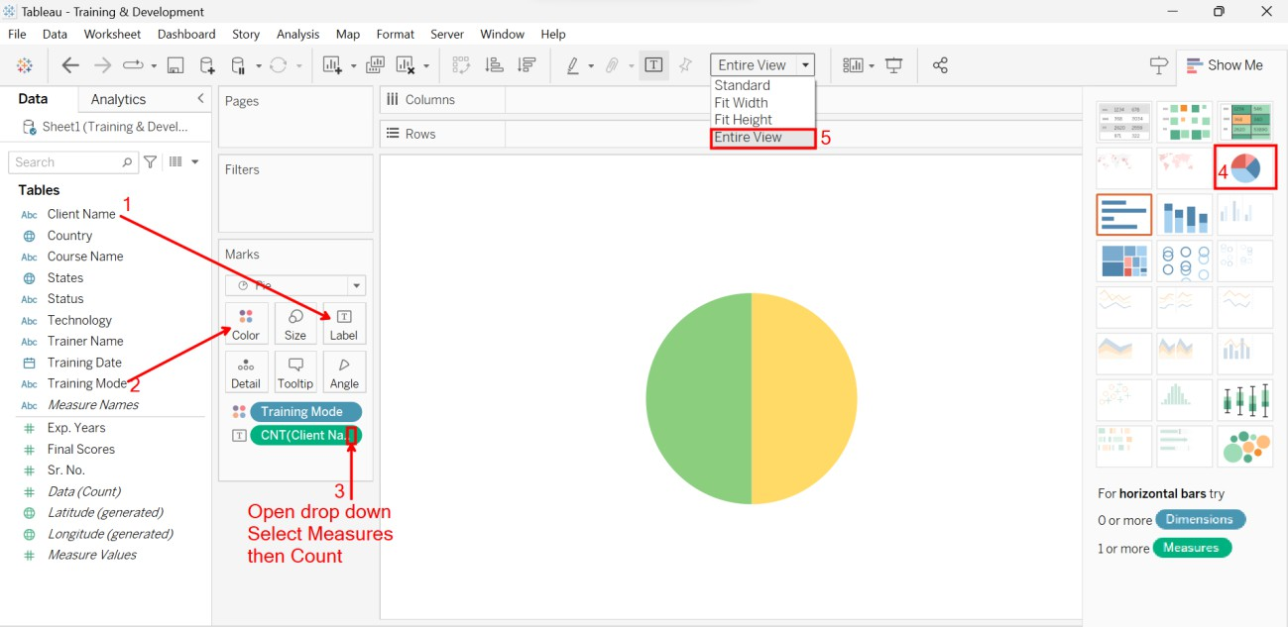

**Step 6:** Drag the Training Mode and Client Name field into the label card

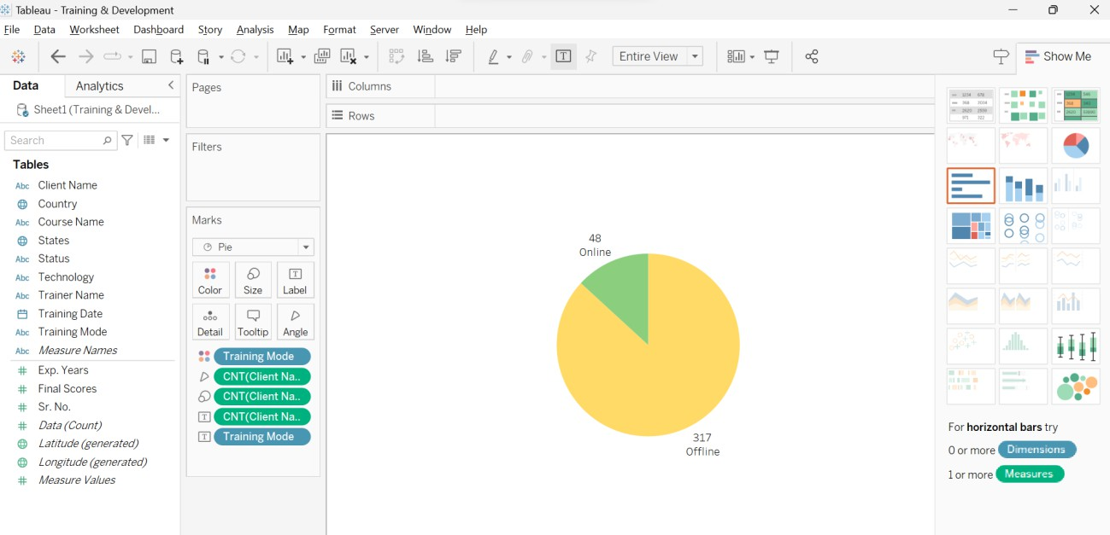

# Make a table with the top 10 training courses by number of clients.

Like:

**Step1:** Drag the Course Name field into the Rows area

**Step2:** Drag the Course Name field into the Text **Step3:** Drag the Course Name field into the Filters **Step4:** Open the drop-down of course name

***Step5:*** *Select the Top Tab* ***Step6:*** *Click on By Field* ***Step7:*** *Select Top*

***Step8:*** *Select 10*

***Step9:*** *Click on OK*

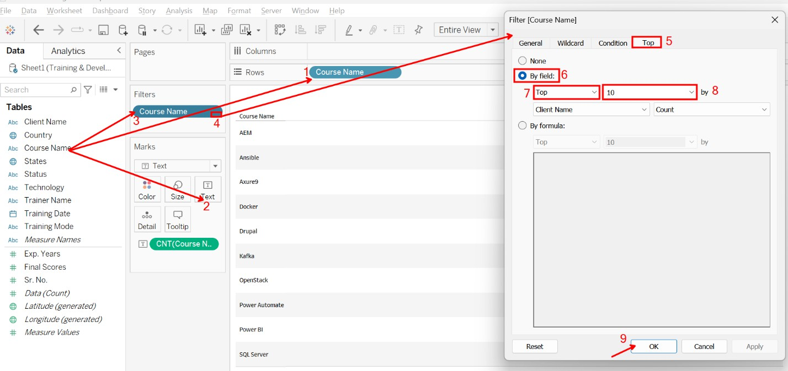

# Map Description automatically generatedMake a map chart showing the number of clients by country.

Like:

**Step1**: Drag the Client Name into the Label **Step2**: Drag the States field into the Label **Step3**: Drag the States field into the Color

**Step4**: Drag the Country field into the Details

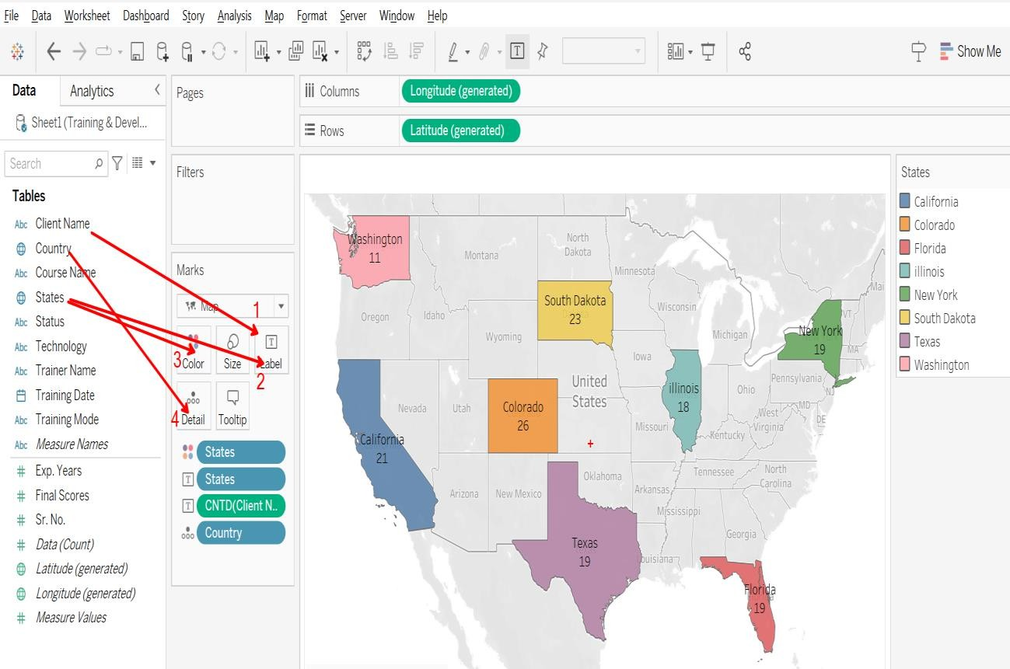

# Create a stacked column chart showing completed and rejected training by month.

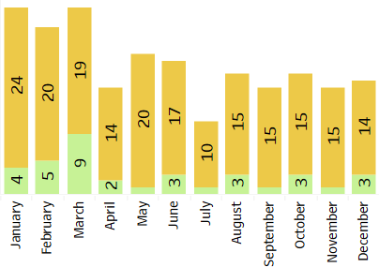

Like:

**Step1**: Drag the Date field into the column area then click on the + (Sign), then show Quarters, then click on the +(Sign), then you will see the Month field

**Step2**: Drag the Client Name field into the rows area

**Step3**: Drag the States field into the Color

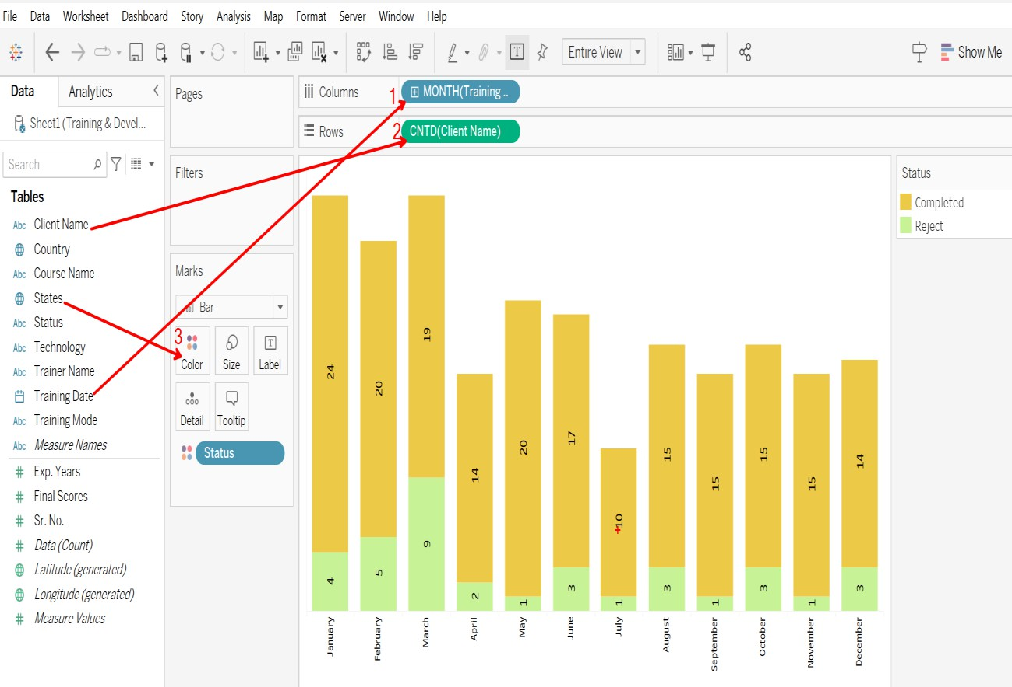

# Chart, line chart Description automatically generatedFor client counts per course name, create a line graph.

Like:

**Step1**: Drag the Course Name field into the Columns area

**Step2**: Drag the Client Name field into the rows area

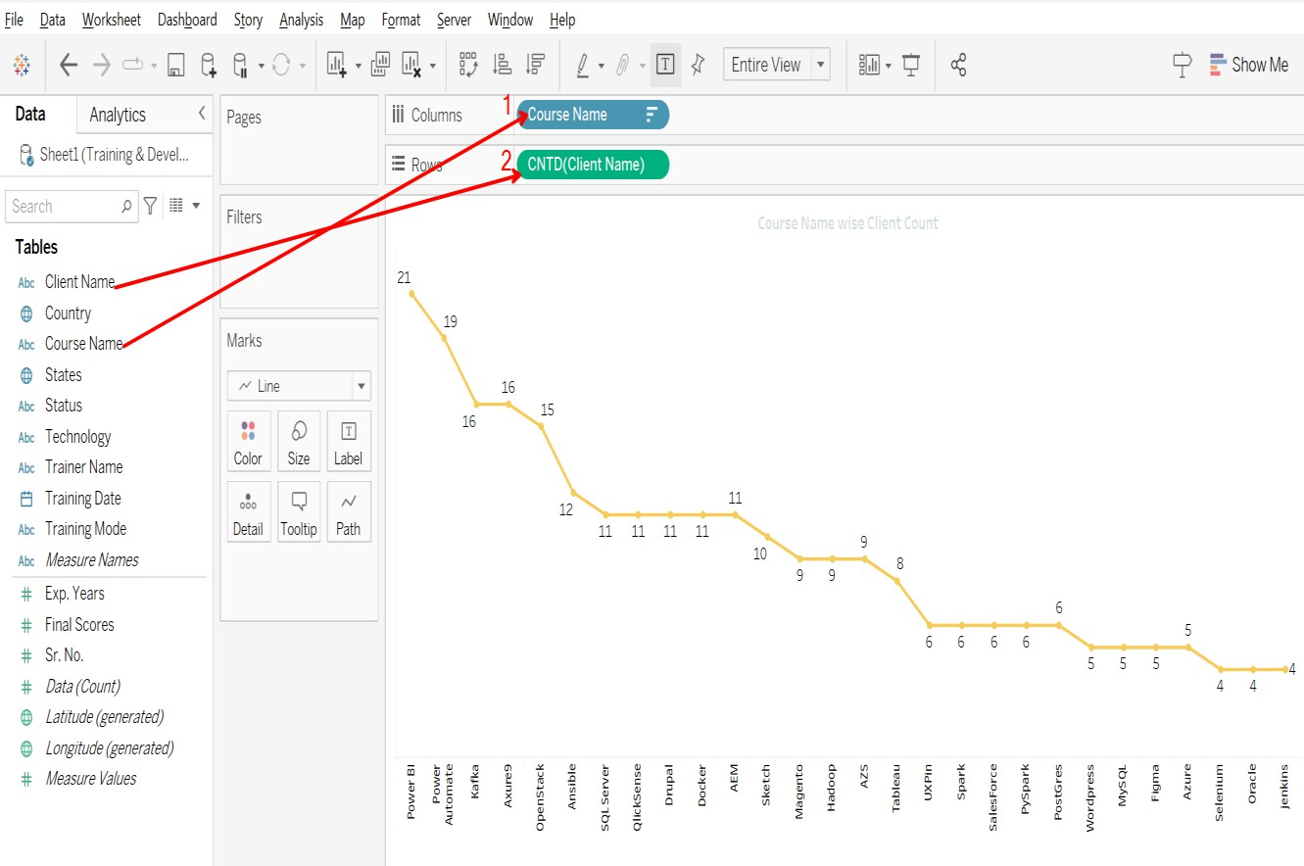

**Final Dashboard**